

**QUESTION 1: CASE STUDY**

TEACHER TRUANCY AND STUDENT DROPOUT

PROBLEM STATMENT



1.

Out

of

the

total

1200

tribal

habitations

in

a

State,

schools

were

there

only

in

824

habitations

.

Even

in

the

existing

schools,

teacher

truancy

has

been

a

major

issue,

resulting

in

the

high

dropout

rate

of

more

than

80

from

class

1

to

5

.

2.

Three

years

later

,

when

the

system

was

checked,

it

was

found

that

the

drop

-

out

rate

had

not

improved,

and

the

teacher

truancy

remained

the

same

.

All

the

tribal

youth

appointed

as

teachers

shifted

their

residence

to

the

nearest

town

.

GIVEN FACTS



BEFORE POLICY IMPLEMENTATION

•

1200

Habitations

•

824

schools

•

Teacher Truancy

–

High

•

Student Dropout

–

More then 80 from

class 1

-

5

AFTER POLICY IMPLEMENTATION

•

1200

Habitations

•

1200

Schools

•

Teacher Truancy

–

High

•

Student Dropout

–

same

UNDERSTANDING MOTIVE BEHIND POLICY



•

It will take both Time and

funds to educate

a whole new group of teachers for these

areas

•

So In

Haste

Government Appointed Tribal Youth educated Up to Secondary school to

Teach Primary classes.

•

One Side, Looks a

good Initiative

to appoint local youth to teach the children

•

But

without proper Training

, this proved a

Liability

, than asset.

•

Secondary school passed youths are still needed to trained, they really need some

Motivation

to do the Job

, salary

will only give them

reason to spend more



WHAT SHOULD BE

DONE

LETS DISCUSS SOME PROBABLE SOLUTIONS AGAINST

RESPECTIVE PROBLEMS

ABSENTEEISM, WHY PRIMARY KIDS ARE AWAY FROM SCHOOL ?



PROBLEM FACTS

•

Longer Distance between Home and school

•

Family Prefer money over Education/ Parent

arrogance

•

Poor Quality of Infrastructure, classroom,

Toilets, Drinking Water, etc

•

More can be accessed with link at end of the

ppt

PROBABLE SOLUTIONS

•

Location Based, Mobile Schools Can be Set up,

in Panchayats/ Mohalla/ Chopals

•

Involve Parents in the Teaching Practices ex. Kid

explaining what his/her Family do for Living, kids

learn what diff. the can make with Education

•

This Is Primary Duty of Gov. To ensure Proper

Facilities

TEACHER TRUANCY, WHY TEACHER ARE LEAVING SCHOOLS?



PROBLEM FACTS

•

Lack Of Proper Training

•

New Teachers Are not able to Connect with the

Problems of Students

•

Higher salary tend to think about better Lifestyle

Approach

•

Youth want to Educate themselves, and Pursuit

their own Dream

s

•

More with links at end of ppt

PROBABLE SOLUTIONS

•

The Chief Reason Behind Truancy

•

New Teachers might not be able to Understand

the Needs of children

•

Incentive Based Pay should Be Tried, So that

teacher Try to Help Student Learn

•

10

th

passed youth have their own Dreams To be

Given time, when some one get finances they first

work on themselves first

# A REAL LIFE EXAMPLE

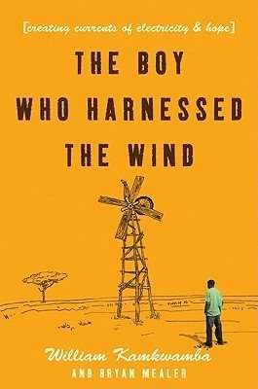

**The Boy Who Harnessed the Wind: Creating Currents of**

**Electricity and Hope**

**–**

[William Kamkwamb](https://www.goodreads.com/author/show/2908712.William_Kamkwamba)

[a](https://www.goodreads.com/author/show/2908712.William_Kamkwamba)

William Kamkwamba was born in Malawi, a country where

magic ruled and modern science was mystery. It was also

a land withered by drought and hunger, and a place

where hope and opportunity were hard to find. But

William had read about windmills in a book called Using

Energy, and he dreamed of building one that would bring

electricity and water to his village and change his life and

the lives of those around him. His neighbors may have

mocked him and called him misala

—

crazy

—

but William

was determined to show them what a little grit and

ingenuity could do.

The Boy Who Harnessed the Wind will inspire anyone who doubts the power of one individual's ability to change his community and better the lives of those around him.



Resources Used

•

[**Absenteeis**](https://www.thehindu.com/news/national/tamil-nadu/absenteeism-a-perennial-problem-in-gtr-schools/article2570248.ece)

[**m**](https://www.thehindu.com/news/national/tamil-nadu/absenteeism-a-perennial-problem-in-gtr-schools/article2570248.ece)

[-](https://www.thehindu.com/news/national/tamil-nadu/absenteeism-a-perennial-problem-in-gtr-schools/article2570248.ece)

[https://www.thehindu.com/news/national/tami](https://www.thehindu.com/news/national/tamil-nadu/absenteeism-a-perennial-problem-in-gtr-schools/article2570248.ece)

[l](https://www.thehindu.com/news/national/tamil-nadu/absenteeism-a-perennial-problem-in-gtr-schools/article2570248.ece)

[-](https://www.thehindu.com/news/national/tamil-nadu/absenteeism-a-perennial-problem-in-gtr-schools/article2570248.ece)

[nadu/absenteeis](https://www.thehindu.com/news/national/tamil-nadu/absenteeism-a-perennial-problem-in-gtr-schools/article2570248.ece)

[m](https://www.thehindu.com/news/national/tamil-nadu/absenteeism-a-perennial-problem-in-gtr-schools/article2570248.ece)

[-](https://www.thehindu.com/news/national/tamil-nadu/absenteeism-a-perennial-problem-in-gtr-schools/article2570248.ece)

[a](https://www.thehindu.com/news/national/tamil-nadu/absenteeism-a-perennial-problem-in-gtr-schools/article2570248.ece)

[-](https://www.thehindu.com/news/national/tamil-nadu/absenteeism-a-perennial-problem-in-gtr-schools/article2570248.ece)

[perennia](https://www.thehindu.com/news/national/tamil-nadu/absenteeism-a-perennial-problem-in-gtr-schools/article2570248.ece)

[l](https://www.thehindu.com/news/national/tamil-nadu/absenteeism-a-perennial-problem-in-gtr-schools/article2570248.ece)

[-](https://www.thehindu.com/news/national/tamil-nadu/absenteeism-a-perennial-problem-in-gtr-schools/article2570248.ece)

[proble](https://www.thehindu.com/news/national/tamil-nadu/absenteeism-a-perennial-problem-in-gtr-schools/article2570248.ece)

[m](https://www.thehindu.com/news/national/tamil-nadu/absenteeism-a-perennial-problem-in-gtr-schools/article2570248.ece)

[-](https://www.thehindu.com/news/national/tamil-nadu/absenteeism-a-perennial-problem-in-gtr-schools/article2570248.ece)

[i](https://www.thehindu.com/news/national/tamil-nadu/absenteeism-a-perennial-problem-in-gtr-schools/article2570248.ece)

[n](https://www.thehindu.com/news/national/tamil-nadu/absenteeism-a-perennial-problem-in-gtr-schools/article2570248.ece)

[-](https://www.thehindu.com/news/national/tamil-nadu/absenteeism-a-perennial-problem-in-gtr-schools/article2570248.ece)

[gt](https://www.thehindu.com/news/national/tamil-nadu/absenteeism-a-perennial-problem-in-gtr-schools/article2570248.ece)

[r](https://www.thehindu.com/news/national/tamil-nadu/absenteeism-a-perennial-problem-in-gtr-schools/article2570248.ece)

[-](https://www.thehindu.com/news/national/tamil-nadu/absenteeism-a-perennial-problem-in-gtr-schools/article2570248.ece)

[schools/article2570248.ec](https://www.thehindu.com/news/national/tamil-nadu/absenteeism-a-perennial-problem-in-gtr-schools/article2570248.ece)

[e](https://www.thehindu.com/news/national/tamil-nadu/absenteeism-a-perennial-problem-in-gtr-schools/article2570248.ece)

•

**Teacher Truancy**

–

[https://www.educationworld.in/addres](https://www.educationworld.in/address-teacher-truancy-)

[s](https://www.educationworld.in/address-teacher-truancy-)

[-](https://www.educationworld.in/address-teacher-truancy-)

[teache](https://www.educationworld.in/address-teacher-truancy-)

[r](https://www.educationworld.in/address-teacher-truancy-)

[-](https://www.educationworld.in/address-teacher-truancy-)

[truanc](https://www.educationworld.in/address-teacher-truancy-)

[y](https://www.educationworld.in/address-teacher-truancy-)

[-](https://www.educationworld.in/address-teacher-truancy-)

•

**A Real Life Example**

[https://www.goodreads.com/book/show/641988](https://www.goodreads.com/book/show/6419887-the-boy-who-harnessed-the-wind)

[7](https://www.goodreads.com/book/show/6419887-the-boy-who-harnessed-the-wind)

[-](https://www.goodreads.com/book/show/6419887-the-boy-who-harnessed-the-wind)

[th](https://www.goodreads.com/book/show/6419887-the-boy-who-harnessed-the-wind)

[e](https://www.goodreads.com/book/show/6419887-the-boy-who-harnessed-the-wind)

[-](https://www.goodreads.com/book/show/6419887-the-boy-who-harnessed-the-wind)

[bo](https://www.goodreads.com/book/show/6419887-the-boy-who-harnessed-the-wind)

[y](https://www.goodreads.com/book/show/6419887-the-boy-who-harnessed-the-wind)

[-](https://www.goodreads.com/book/show/6419887-the-boy-who-harnessed-the-wind)

[wh](https://www.goodreads.com/book/show/6419887-the-boy-who-harnessed-the-wind)

[o](https://www.goodreads.com/book/show/6419887-the-boy-who-harnessed-the-wind)

[-](https://www.goodreads.com/book/show/6419887-the-boy-who-harnessed-the-wind)

[harnesse](https://www.goodreads.com/book/show/6419887-the-boy-who-harnessed-the-wind)

[d](https://www.goodreads.com/book/show/6419887-the-boy-who-harnessed-the-wind)

[-](https://www.goodreads.com/book/show/6419887-the-boy-who-harnessed-the-wind)

[th](https://www.goodreads.com/book/show/6419887-the-boy-who-harnessed-the-wind)

[e](https://www.goodreads.com/book/show/6419887-the-boy-who-harnessed-the-wind)

[-](https://www.goodreads.com/book/show/6419887-the-boy-who-harnessed-the-wind)

[win](https://www.goodreads.com/book/show/6419887-the-boy-who-harnessed-the-wind)

[d](https://www.goodreads.com/book/show/6419887-the-boy-who-harnessed-the-wind)

**Absenteeism &**

**Teacher Truancy**



Github

Link for More Recommendations

And/or Solutions to the Two Major

Problems

–

[https://github.com/Rajnikant21/Cris](https://github.com/Rajnikant21/Crisp-Question-1-Recommendations)

[p](https://github.com/Rajnikant21/Crisp-Question-1-Recommendations)

[-](https://github.com/Rajnikant21/Crisp-Question-1-Recommendations)

[Questio](https://github.com/Rajnikant21/Crisp-Question-1-Recommendations)

[n](https://github.com/Rajnikant21/Crisp-Question-1-Recommendations)

[-](https://github.com/Rajnikant21/Crisp-Question-1-Recommendations)

[1](https://github.com/Rajnikant21/Crisp-Question-1-Recommendations)

[-](https://github.com/Rajnikant21/Crisp-Question-1-Recommendations)

[Recommendation](https://github.com/Rajnikant21/Crisp-Question-1-Recommendations)

[s](https://github.com/Rajnikant21/Crisp-Question-1-Recommendations)



**QUESTION 2: ANALYTICAL QUESTION**

“India’s Economic Growth has a far greater impact on

poverty alleviation than measures to reduce inequality”.

Examine critically. Do you agree with the statement? If so,

why? If not, give reasons and your suggestions.

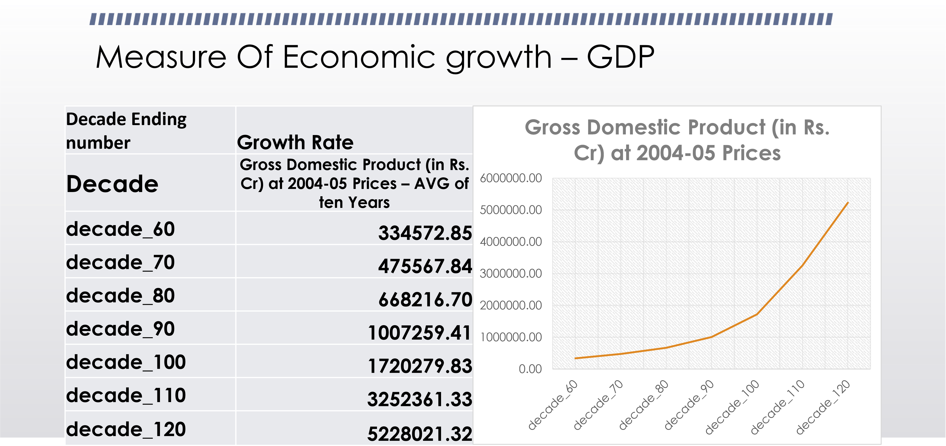



Poverty Alleviation

2600

2700

2800

2900

3000

3100

3200

3300

Number of Persons Below Poverty Line in India

Poverty In India

Series1

Series2

Series3

Series5

Series6

**Years**

**1973**

**1983**

**1993**

**2004**

**2013**

**2023**

Number

of Persons

Below

Poverty

Line in

Rural

India

2612.9

2519.57

2440.31

2209.24

2090.04

1964.57

Number

of Persons

Below

Poverty

Line in

Urban

India

600.46

709.4

763.37

807.96

893.04

964.43

**Number**

**of Persons**

**Below**

**Poverty**

**Line in**

**India**

**3213.36**

**3228.97**

**3203.68**

**3017.2**

**2955.67**

**2870.51**

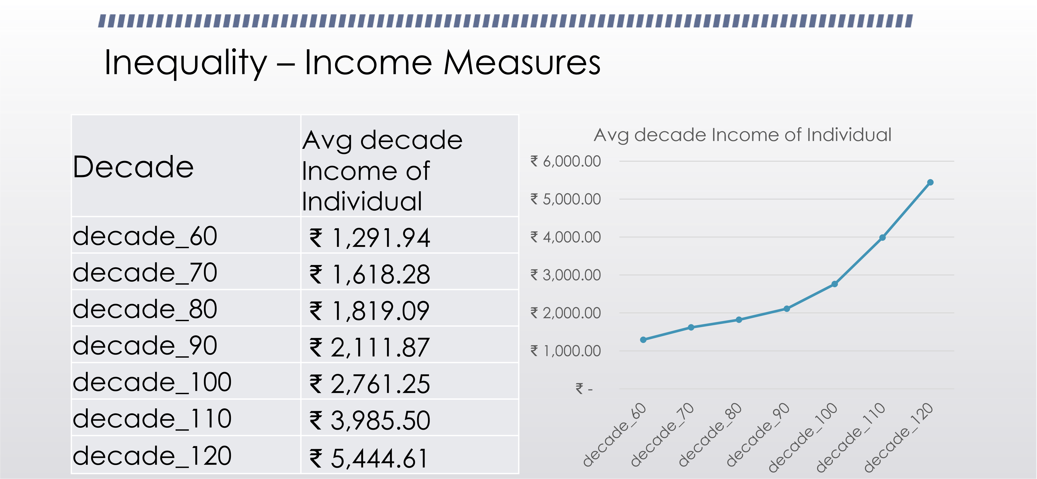



Insights And Data Sources

•

I find out that there is Direct Relation Between Economic Growth, Poverty Alleviation and

Inequality(Financial). So I Do not Agreee With Given Statement.

•

More Detailed Report can Be Found on Given Link

.

•

Data Source

–

[https://data.gov.in](https://data.gov.in/)

[/](https://data.gov.in/)

•

More Detailed Report

-

[https://github.com/Rajnikant21/Questio](https://github.com/Rajnikant21/Question-2-Crisp-Problem-Statement)

[n](https://github.com/Rajnikant21/Question-2-Crisp-Problem-Statement)

[-](https://github.com/Rajnikant21/Question-2-Crisp-Problem-Statement)

[2](https://github.com/Rajnikant21/Question-2-Crisp-Problem-Statement)

[-](https://github.com/Rajnikant21/Question-2-Crisp-Problem-Statement)

[Cris](https://github.com/Rajnikant21/Question-2-Crisp-Problem-Statement)

[p](https://github.com/Rajnikant21/Question-2-Crisp-Problem-Statement)

[-](https://github.com/Rajnikant21/Question-2-Crisp-Problem-Statement)

[Proble](https://github.com/Rajnikant21/Question-2-Crisp-Problem-Statement)

[m](https://github.com/Rajnikant21/Question-2-Crisp-Problem-Statement)

[-](https://github.com/Rajnikant21/Question-2-Crisp-Problem-Statement)

[Statemen](https://github.com/Rajnikant21/Question-2-Crisp-Problem-Statement)

[t](https://github.com/Rajnikant21/Question-2-Crisp-Problem-Statement)

•

Detailed Data is put on

-

-

[https://github.com/Rajnikant21](https://github.com/Rajnikant21/)

[/](https://github.com/Rajnikant21/)